**Excel Assignment - 10**

*1. See the below picture and create the exact table with exact formatting.*

*Font – ‘Times New Roman’ Size – 14, Color of ﬁrst line Orange.*

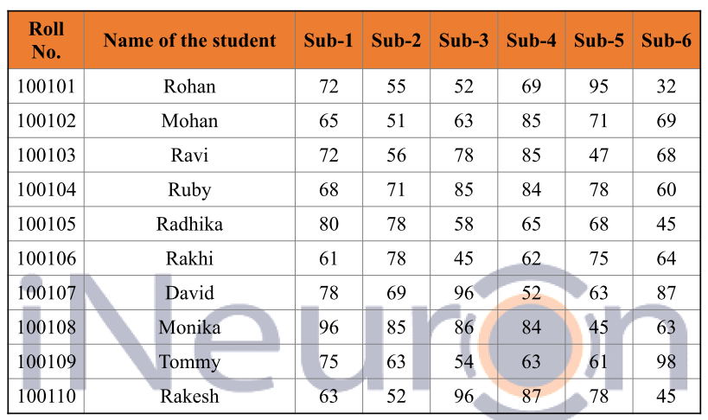

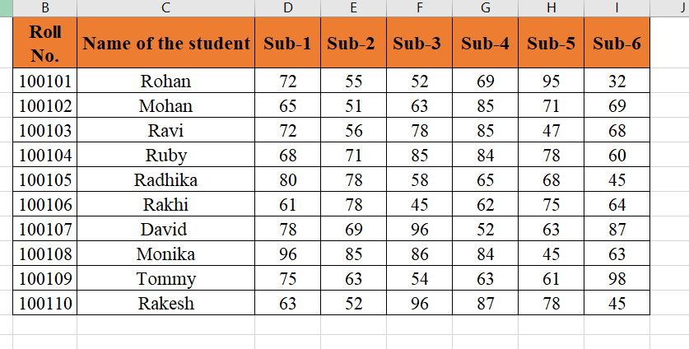

*2. From the above table use Sum Formula and ﬁnd the total for each student.*

*1.*We can Autosum function to sum the total subjects marks.

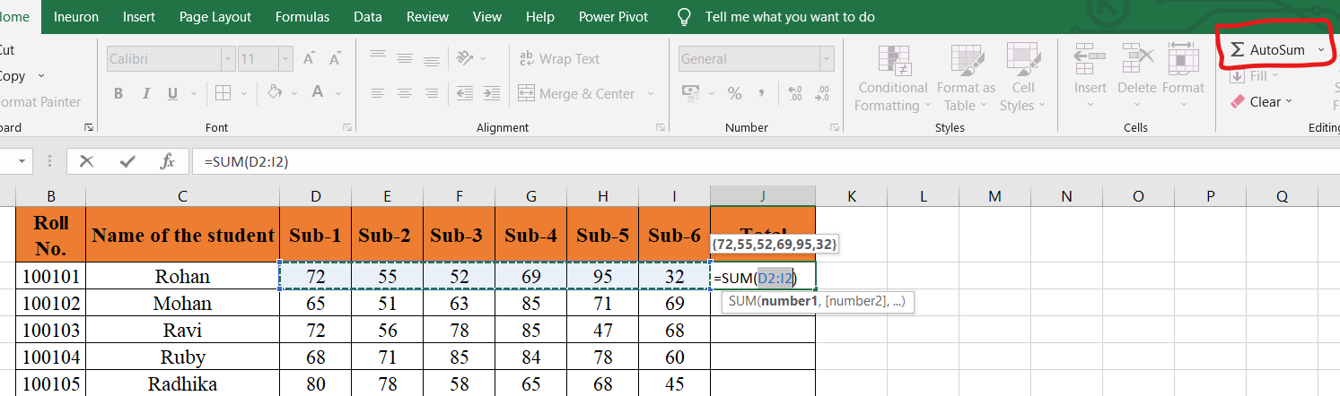

*2.*Drag down the formula below so that each student marks can be totaled.

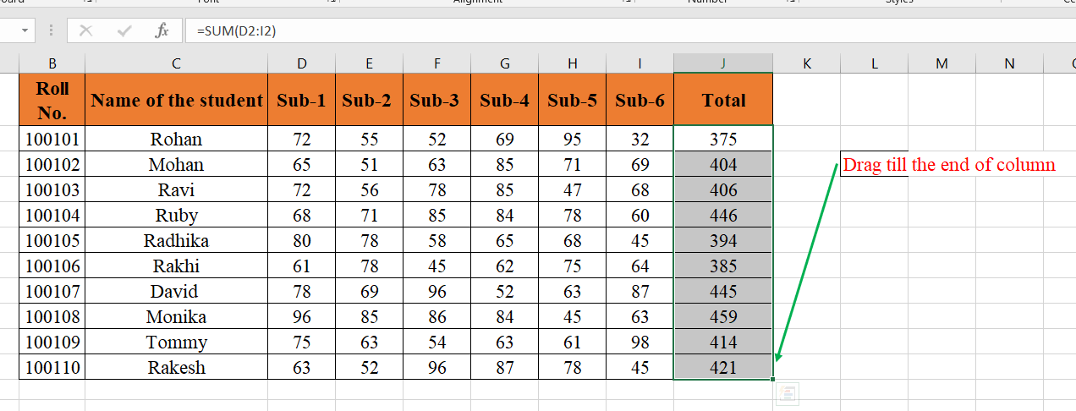

*3. Calculate Average for each student in the next row. Use Formulas.*

*1.*We can Average function to average the total subjects marks.

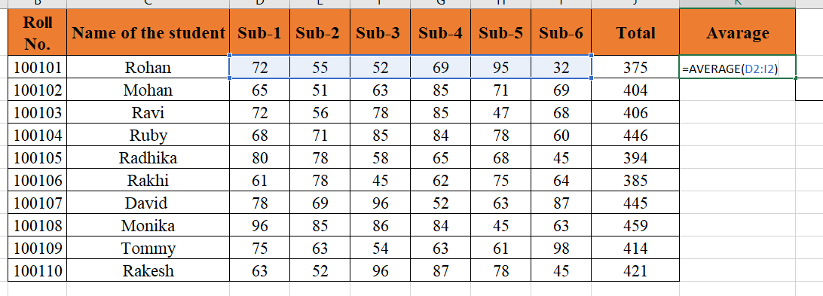

*2.*Drag down the formula below so that each student marks can be Avarage out

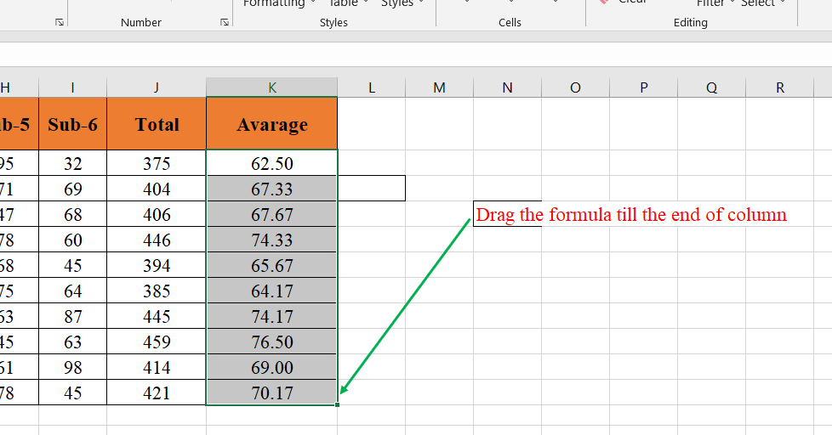

*4. Calculate Rank for each student. Use Formulas.*

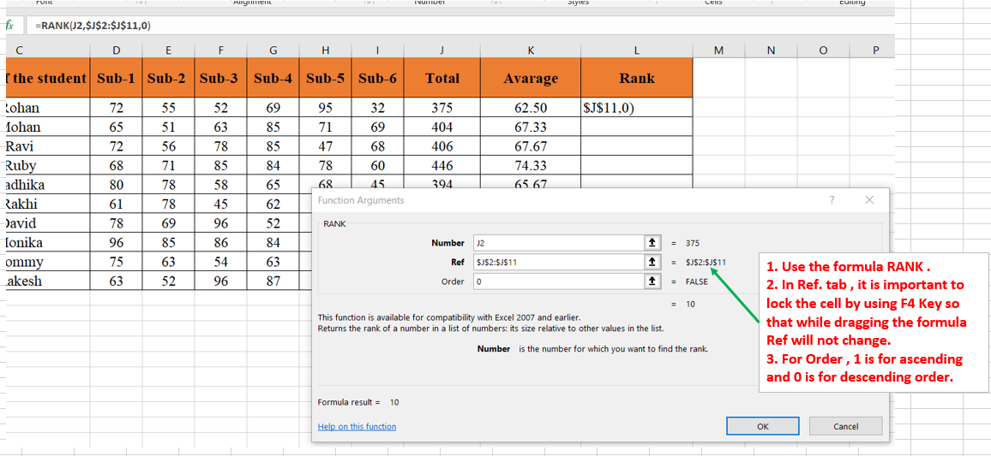

2. Drag down the formula below so that each student Rank will be calculated.

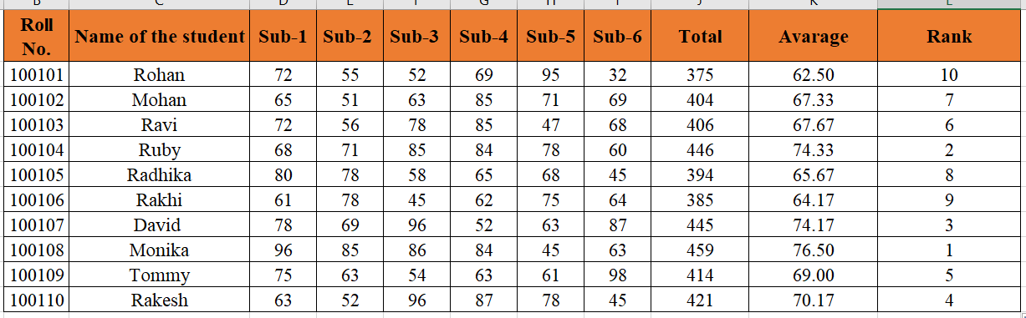

*5. Calculate Percentage for each student. Use Formulas. Round oﬀ the decimals up to 2 points.*

1. Suppose each subject is of 100 marks so total subject marks are 600.

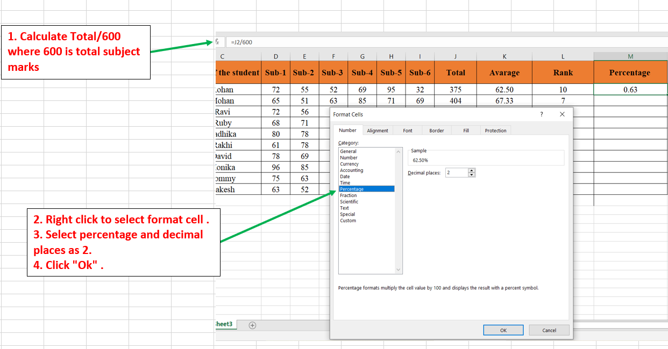

2. Drag down the formula to calculate each student percentage.

